**Subject: Mobile Application Design**

**Assignment 1**

**Group Members**

**Chanchal Pauly Thattil**

**Negin Adibi**

**Kavitha Vijayan**

**Sonalben Chauhan**

**App idea: Indian Restaurant Mobile application**

Restaurant mobile apps help to deliver the trending customer experience with advanced functionalities to reserve a table in advance or order food at home. The fully functional mobile app helps you to interact and connect with your customers. Order food online, reserve seats and book for events.

1. **Intended users of application:**

The people who want to order food from the Restaurant and book reservations and find the offers and menu details.

As it is an Indian restaurant, we assume that our most customers will be Indians who live in Waterloo, Kitchener area.

Since there are so many Indian students who study in waterloo the region, the expected audiences will be Indian students between the age 19 to 35. From this student’s group, male students may be the ones who would be the main customers compared to female students as male students are less interested in cooking.

We are planning to make a food menu in a way that can afford by people with low income also. As most of the customers will be students, they will have a limited income only.

The customers will use this app mostly to order food online, and check offers and promotions (There will be some offers only for mobile app users.). Also making reservations for parties and events. We are planning to have discounts for people who download the app for the first time. There will be cashback offered so people will tend to use it again.

The app users can book the student zone using the app and they can have food and study and borrow laptops using free Wi-Fi.

The app users can get referral bonus points who refer the app to others using their referral code.

For feedback, complaints, and suggestions, there will be options available in the application.

There will be different cuisines available from different parts of India and it will attract more people to use the mobile application.

People in every economic background will be using this app as in very price there will be items available.

People with every educational background will be using this app as most of the people are familiar with the mobile applications and know how to use it

1. **Business case for development of app**

This app comes under the category of Travel and Hospitality.

Benefits of restaurant app development:

* To search for restaurants, menus, locations and hours of operation 83 % of adults use their mobile phones or tablets.
* 3 out of 4 customers prefers to use restaurant when there is no crowd.
* 79% agree that restaurant technologies attract them more into the place.
* 36% agree that the feature to book a table online is a necessary feature.
* Four in five restaurant owners says that mobile application helped them with increase sales, and attracted more customers.

Features

* Online ordering and pre- ordering
* Payment processing
* Customized menu
* Online table reservation
* Location and map
* Push notifications (offers, deals, news and promotions)
* Loyalty programs
* Ratings and Reviews
* Buffets
* Student corner
* Kids menu
* Referral bonus
* Cashbacks
* Filters and sorting
* Calendar events
* Order tracking
* Points, Coupons and events
* In app calling

**Cost for developing the app:**

Project, database setup – 32 hours

Home page – 20 hours

Gallery – 9 hours

Menu – 78 hours

Order delivery – 56 hours

Map – 13 hours

Book a seat – 34 hours

Cart – 25 hours

Checkout – 36 hours

Orders – 35 hours

Payment gateway – 21 hours

Notifications – 14 hours

Profile – 28 hours

Settings – 12 hours

Coupons – 12 hours

Events – 9 hours

So, total hours will be 434 hours and if we imagine 35 CAD per hour, total cost will be 15,190 CAD.

**Revenue streams**

* **Delivery charges**

It can be a percentage of total amount or a flat fee. Delivery charges are a way for stable income. But avoiding delivery charges for more than some amount purchase can attract more customers.

* **In app purchases**

Uses app as another sales channel. It is important that the app should remain functional without any digital upgrades. It can refer to ad removal, virtual currency

* **Freemium app model**

Offers free basic and premium versions of your app. It is to create a customer base and attract more to pay for exclusive features

* **Social media outreach**

Selling cookies to other websites who needs to know the customer preferences

* **More customers and sales**

Having a mobile app and services can attract more online orders and more customers.

1. 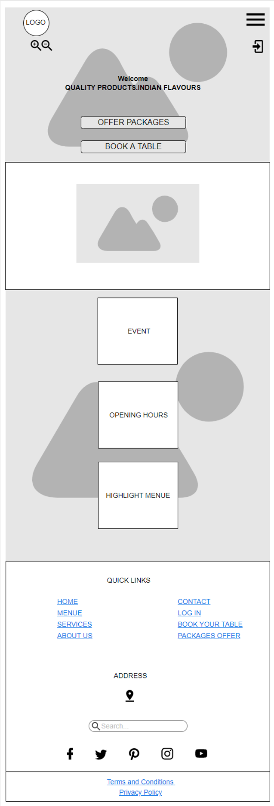**Moqup**

 